URL : https://www.facebook.com/

NOTE: Type email in email textbox and cut the email using Robot class

Paste that email in password text using Robot class

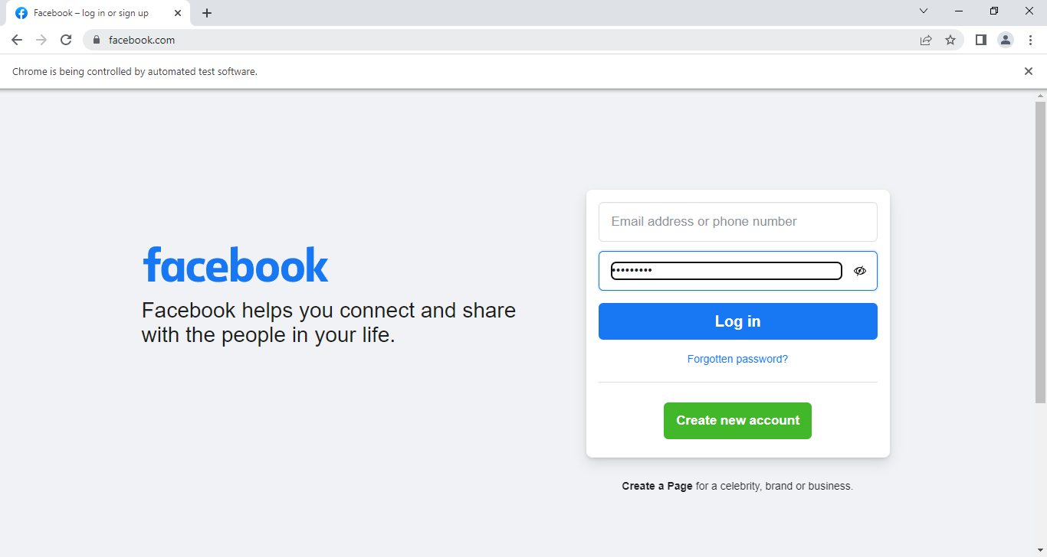

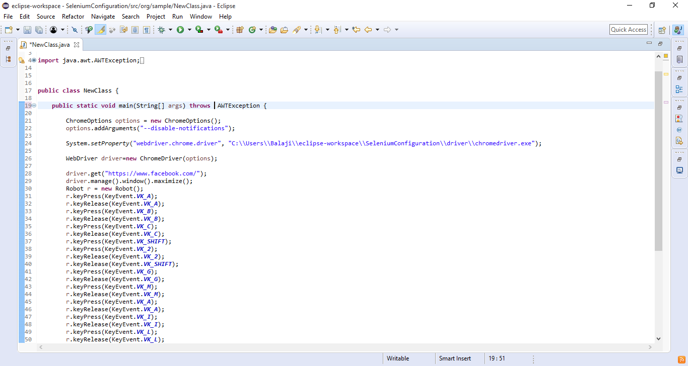 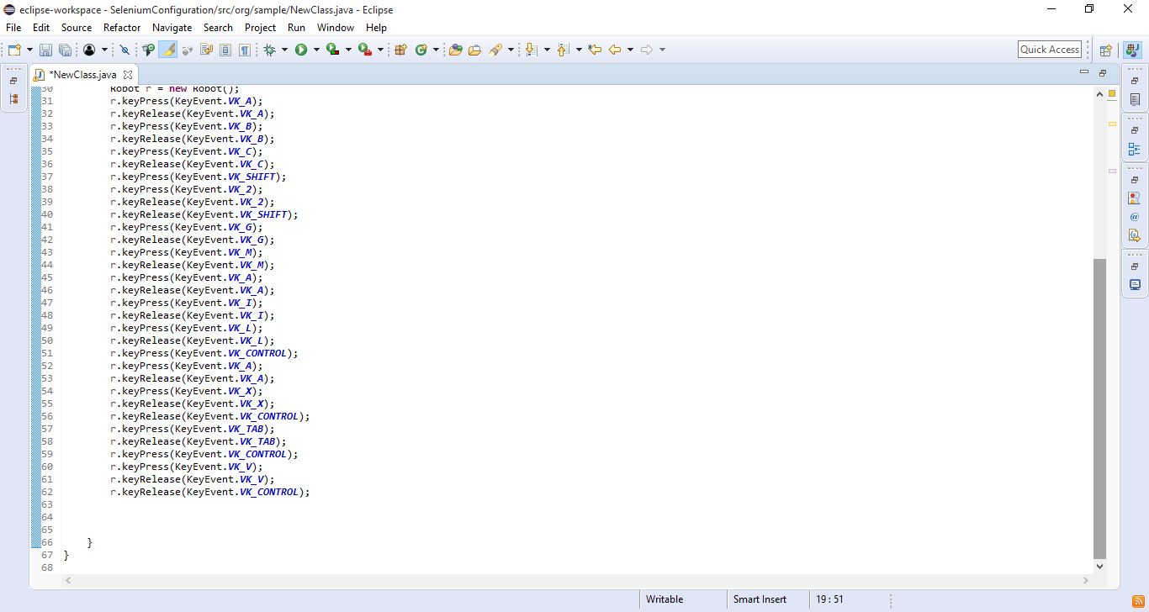

----------

URL : https://www.google.co.in/webhp

NOTE: Enter Vel Murugan and select Vel Murugan using double Click

Cut Vel Murugan using Keyboard shortcut[Ctrl+x]

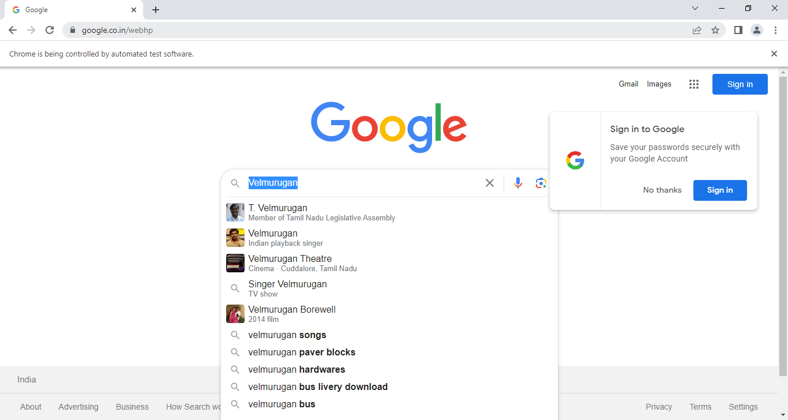

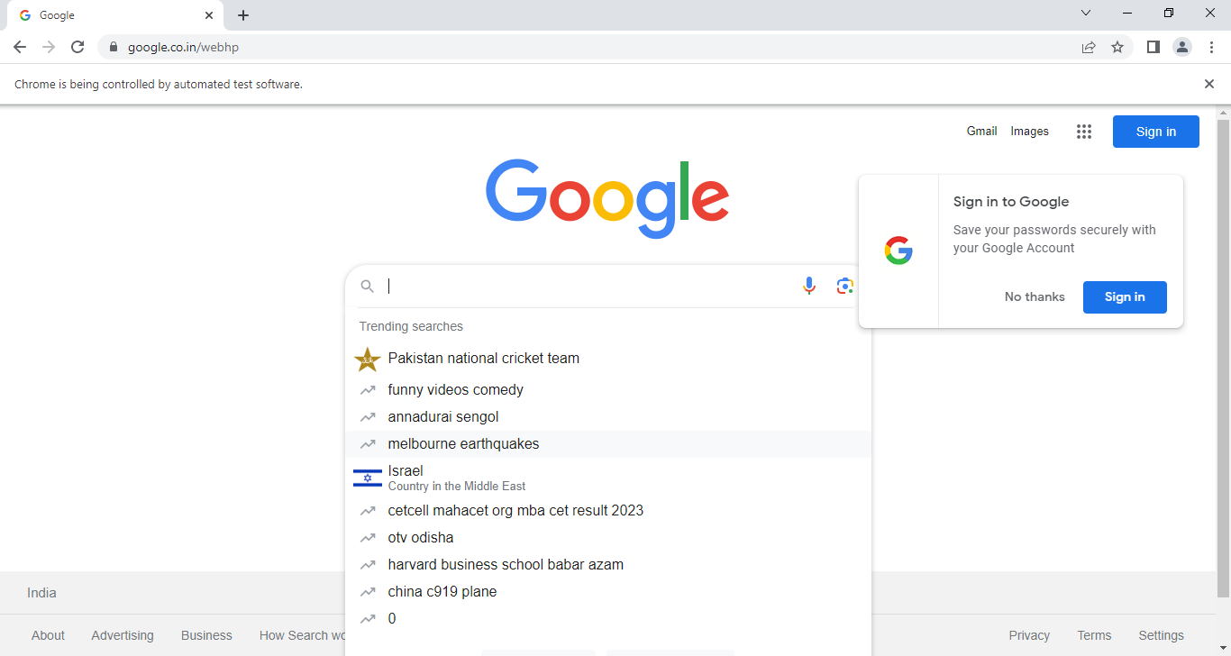

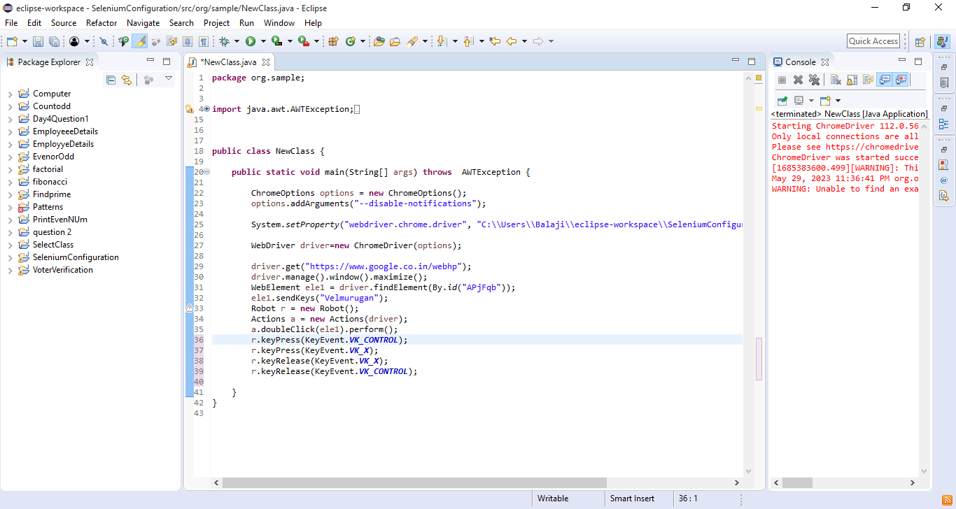

----------

URL : http://greenstech.in/selenium-course-content.html

NOTE: Click interview question and Right click cts interview question and Select open link in new window

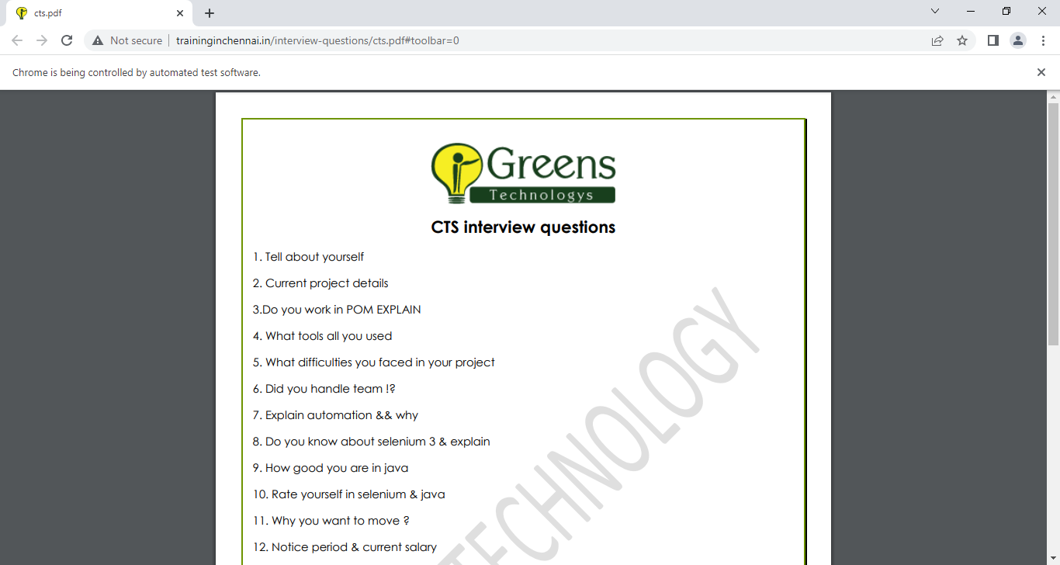

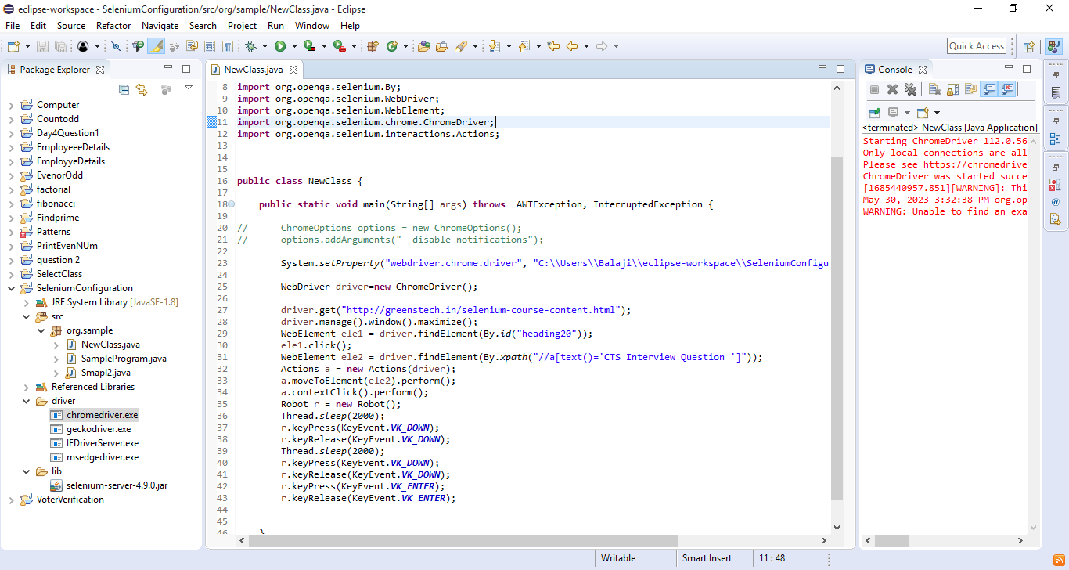

----------

URL : http://greenstech.in/selenium-course-content.html

NOTE: Right Click Framework Test Papers and Select Inspect

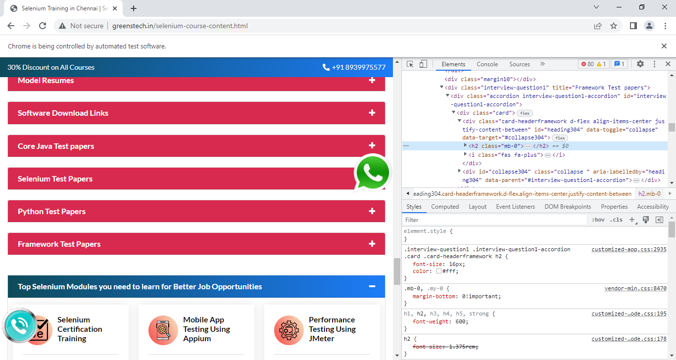

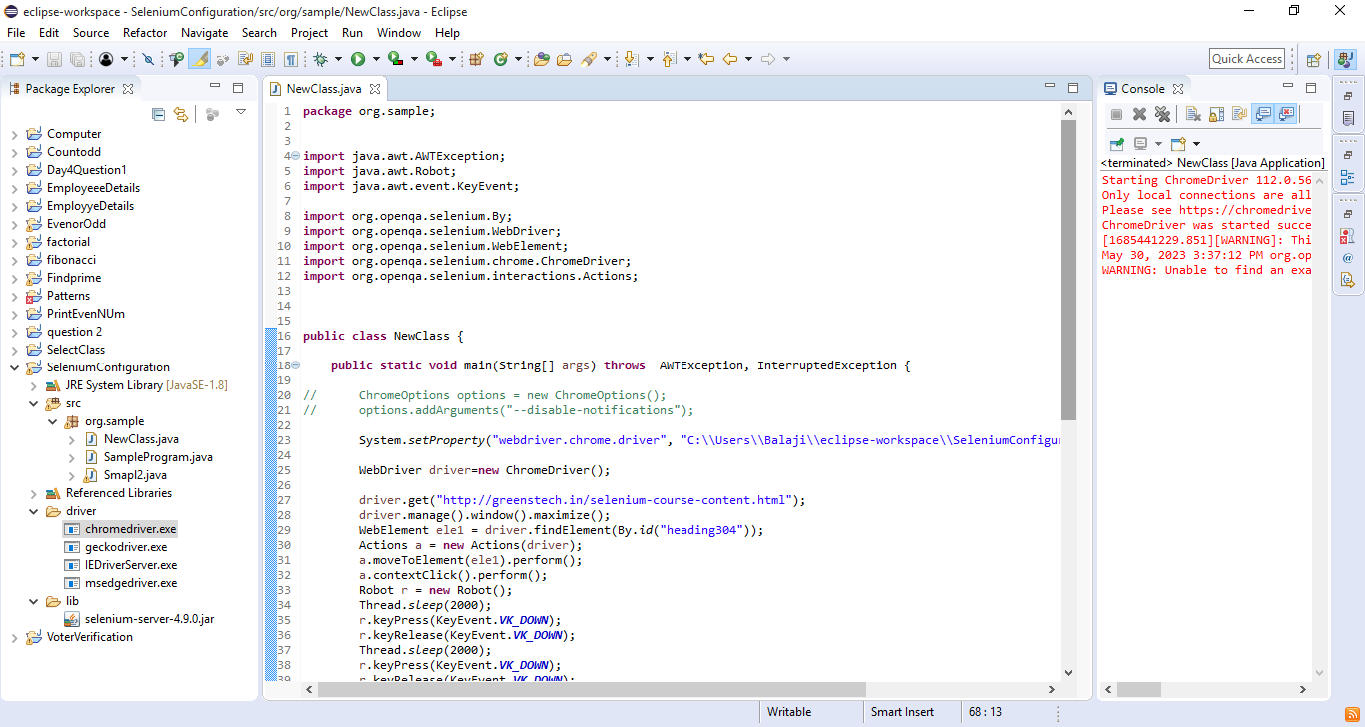

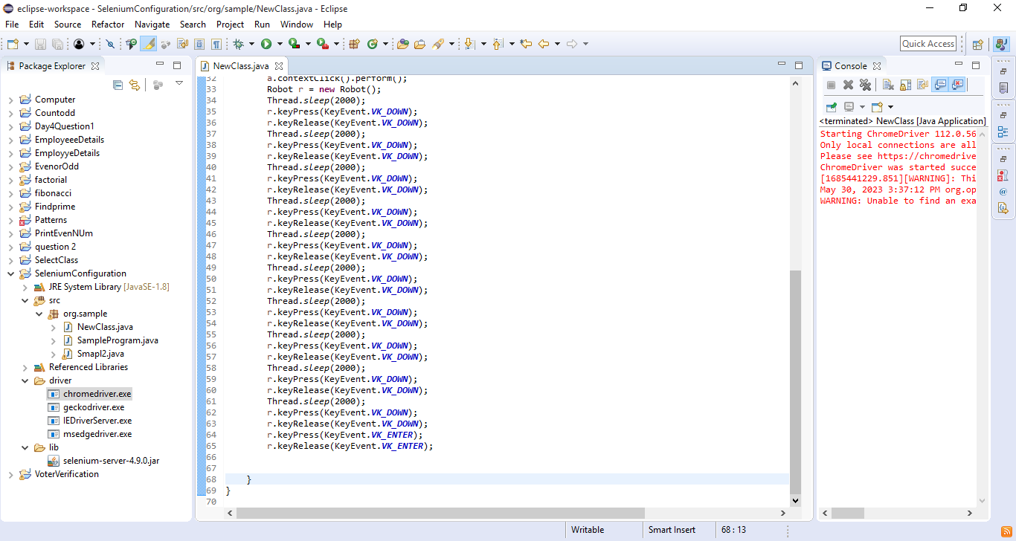

-----------

URL : http://greenstech.in/selenium-course-content.html

NOTE: Click Model Resume and rightClick resume model 4 the page and click save as.

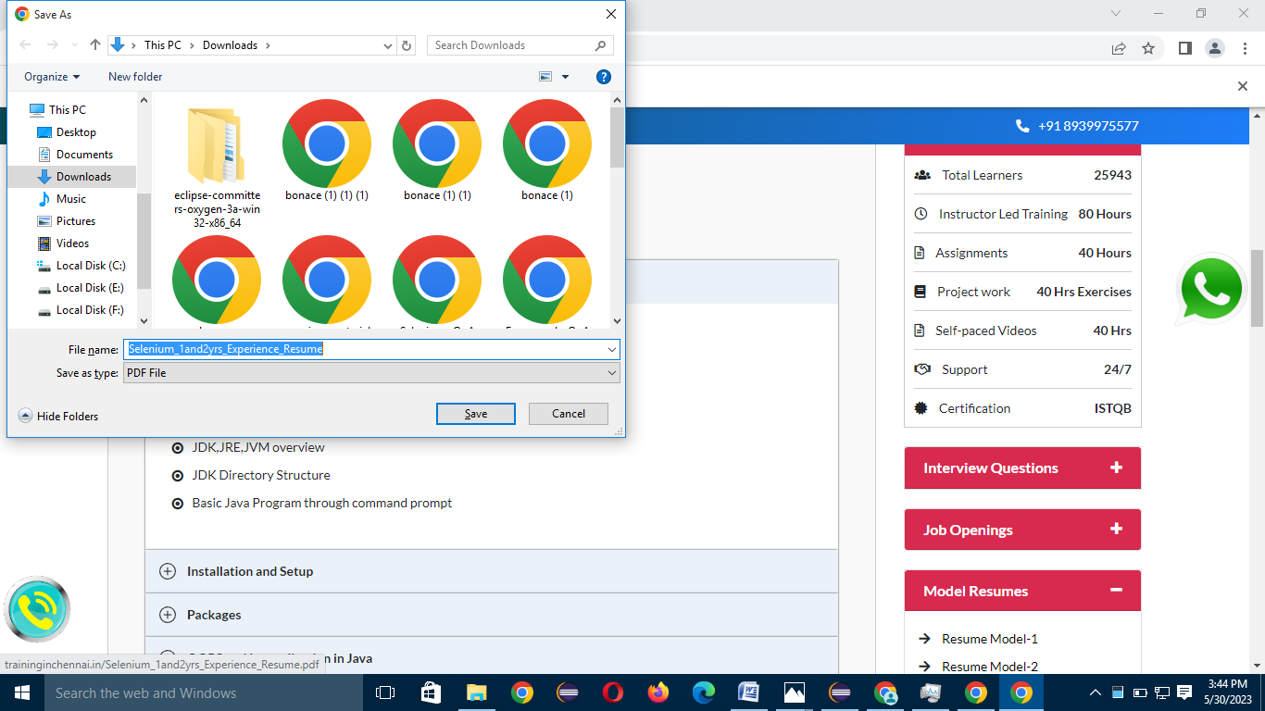

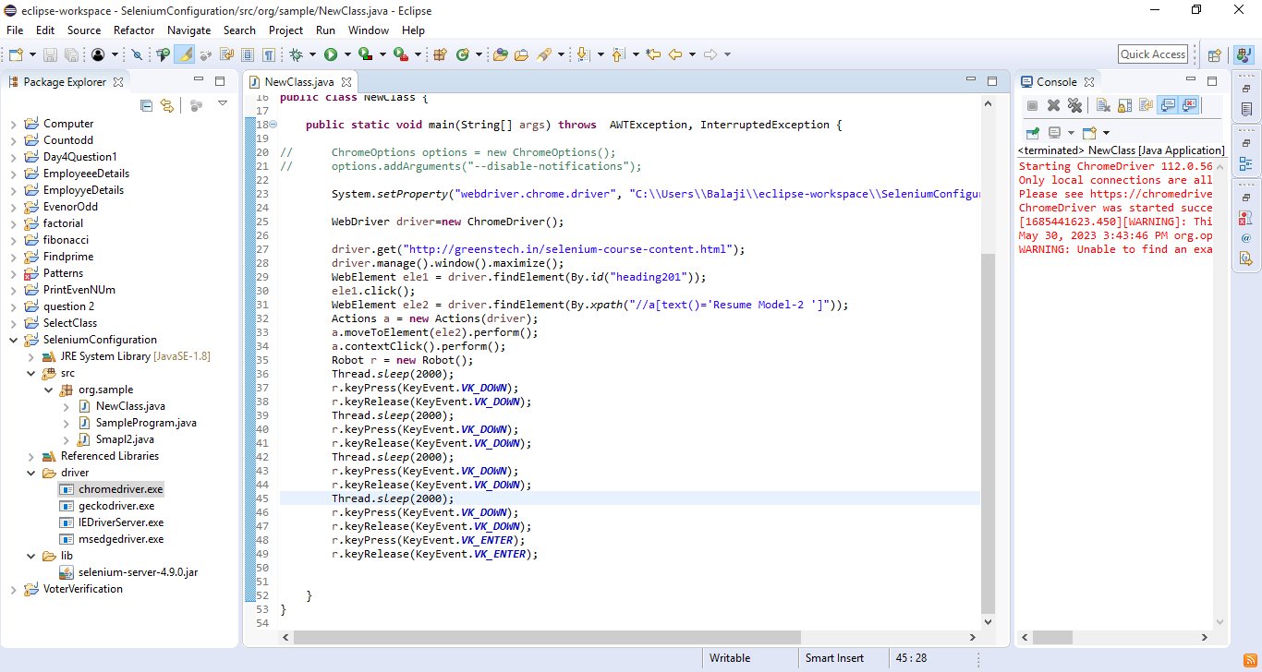

QUESTION

------------

URL : https://www.amazon.in/

NOTE: Click login and type a email in email textbox and select email and right click and click cut

